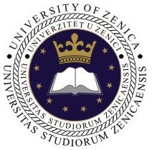 | 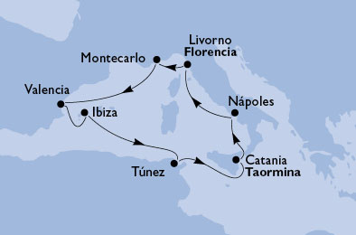  UNIVERSITY OF ZENICA  (Bosnia and Herzegovina) | TMT 2010  Mediterranean Cruise |  | FACULTY OF MECHANICAL  ENGINEERING
 | UNIVERSITAT POLITÈCNICA  DE CATALUNYA (Spain) | TMT 2010  Mediterranean Cruise | 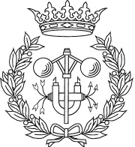 | E.T.S.E.I. de Barcelona  DEPARTAMENT D'ENGINYERIA MECÀNICA | 
 | BAHÇEŞEHİR ÜNİVERSİTESİ  ISTANBUL (Turkey) | TMT 2010  Mediterranean Cruise |  | MÜHENDİSLİK FAKÜLTESİ
14th International Research/Expert Conference
”Trends in the Development of Machinery and Associated Technology”
TMT 2010, Mediterranean Cruise, 10-19 September 2010

REGISTRATION FORM

Please, fill in form bellow:
Title of the paper:
Authors:
Coresponding author:
Institution
(full address)
e-mail:
Abstract:
Topic: | - Manufacturing technologies and materials
Topic: | - Industrial engineering
Topic: | - Applied technologies and software engineering
Topic: | - Mechanical construction and design
Presentation: | - ORAL
Presentation: | - POSTER

Send the form to: tmt@mf.unze.ba

